I Am

I am Raya.
I am loud.
I am obnoxious.
I am beautiful. 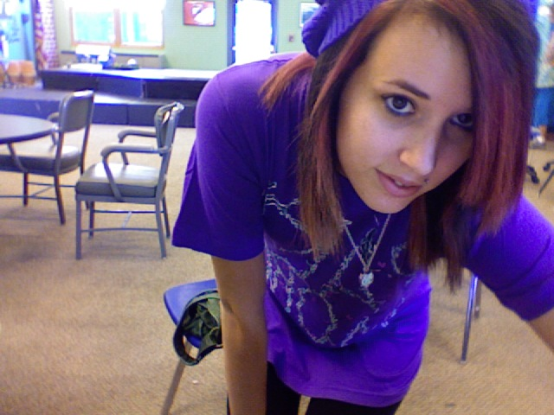
I am random.
I am a singer.
I am a musician.
I am tall.
I am unique.
I am special.
I am colorful.
I am bright.
I am into tattoos.
I am into piercings.
I am a music lover.
I am a lover.
I am a lover of sunny days.
I am going to pursue my education.
I am cute.
I am bubbly.
I am a sister.
I am a daughter.
I am annoying.
I am a DINOSUAR!
I am a writer.
I am a teacher.
I am a learner.
I am a friend.
I am a cartoon lover.
I am skinny.
I am a dreamer.
I am a hopeless romantic.
I am in love with my best friend.
I am amazing.
I am lucky.
I am Raya.

Birth Story

I was born on November 13th, 1993 in Omak, Washington. When I came out I had problems breathing, so I was taken away from my mom right away. My breathing turned out to be okay so they gave me back to my mom. My mom was relived but not for long, my eyes stared rolling in the back of my head. The doctors thought I was having seizures so they flew my mom and me right away to Spokane, in a helicopter from Omak. When we arrived at the hospital in Spokane they did a whole bunch of tests and came to the conclusion that I wasn’t having seizures.

Parents & Siblings

Mom: My mom is a kind heart. She does anything and everything for her family. Her personality is so much fun. Sometimes we don’t get along but I guess that’s just part of relationships. I love her dearly. She’s my best friend.

Dad: Lets see, where to start, my dad is a big kid. He might live about 4 hours away but I know that he will always be there for me. I connect well with him musically. He’s the whole reason I’m so into music.

Mike: Mike is my step-dad. He is a hard worker. I’ve never met a single person that has accepted two kids that aren’t his and treat them as if they were.

Rebecca: Rebecca is my step-mom. She’s a wonderful woman, has a big heart, and is very loving.

Angel: She’s my little sister and regardless of how annoying she is I love her so much. She’s very girly and bubbly.

Loren: Loren is a little monkey boy. Ever since he was little he has always climbed on anything and everything. He’s very spastic and obnoxious.

William: William is the brainiest little kid. I’ve never met such a smart little guy.

Noah: Noah is a big ladies man. He’s a very obnoxious at times.

Zerah: Zerah is the shy and the baby of the bunch. He’s a tiny little boy and a picky eater.

Pivotal Moments

- One event that made a big impact on my life is when I came to Yampah. Yampah made me relies that it’s okay to be who I truly am and that I will always be welcome somewhere.
- Another event is when I competed in Battle of the Bands. That was when I really got over my stage fright and learned that I love to perform.
- The most recent event that changed my life is when I went to the climb for life in Salt lake City, Utah. I had a lot of fun and I really challenged myself physically and mentally.

What Makes Me Happy

- Music
- Guitar
- Photography
- Modeling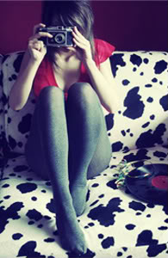
- Singing
- Art
- Acoustic music
- Zombies
- Horror movies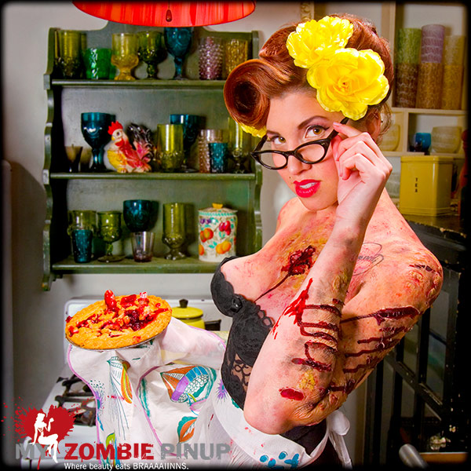
- Live shows
- Food
- Love
- Hope
- Boys
- Best friends
- Smiles
- Sunshine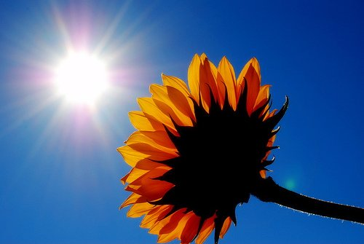
- Photos
- Clothes
- Bright colors
- Bracelets
- Rings
- Hello kitty
- Hearts
- Black and white movies
- Black and white photos
- Boots
- Tattoos
- Piercings
- Your mom jokes
- Good times
- Juice
- Soda
- Rock climbing
- Dancing
- Shopping
- Being with family
- Being with friends
- Coloring books
- Crayons
- My car
- Camping

Things That Make Me sad

- Lack of money
- Rules
- Bad days
- Sad faces on texts
- War
- Bad hair days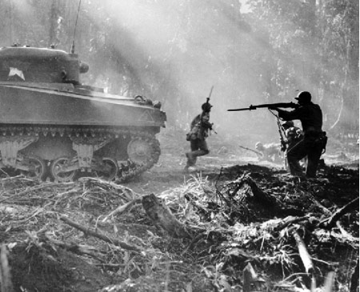
- Being sick
- Being alone
- Sad poems
- Being hurt
- Crying
- Thinking of how much I miss someone
- Snow
- Car crashes
- Global warming
- Not having a cool camera to take photos with
- Arguing with my parents
- Gross food
- Thinking about the future
- Drugs

Strengths, Talents, & Weaknesses

Strengths: My strengths are that I can be strong emotionally when I need to be. I also know when to be a leader and know how to say the right things at the right time.

Talents: I am a musician, a singer, and an artist.

Weaknesses: I am weak when it comes to love. I’ll drop to my knees for someone that I love. I will do anything and everything for the ones I love even if it hurts me in the end.

Religious Beliefs

I don’t have a religion. I was never raised to believe in god or any other higher power. I have never really been raised to believe in anything. I think that once we die we are put into the ground and we rot, unless we didn’t really fulfill our lives to the fullest and if tat’s the case we rome the earth until justice is served, as ghosts of coarse. Religion is not a big part of my life.

Beauty is…

To me beauty is what makes someone who they are, what there hearts make him. If your heart is pure than you are beautiful regardless of what you look like on the outside. Beauty makes the world go around.

Friendship is…

To me friendship is honesty, loyalty, and trust. If you can’t trust them with your secrets than what’s the point? I could never be a friend with someone who lies to me and tells all my secrets to everyone. I need a support system not a blabbermouth.

Parenthood

- Love your kids unconditionally.
- Take care of them no matter how hard it may be.
- Discipline your child appropriately. Don’t be too harsh.

My Future

I need to focus on school. I really want to move to Chicago after a little while and go to college at Columbia University. I want to major in music. After college I want to have a family and settle down somewhere nice and warm.

Success

Success is when you accomplish a goal that you have set for yourself. By my definition, yes, I am successful. I have pushed myself to succeed in everything I do and will continue to do so.

I Am Thankful For…

- Life
- Love
- Family
- Friends
- Happiness
- My car
- My guitar
- My house
- My Mom
- My stepdad
- My Dad
- My step mom
- My siblings
- Music
- Dylan
- Zach
- My Grandma
- My Papa
- Brad
- Tim
- Nick
- My past
- The present
- The future
- Memories
- Photos
- Kisses
- Hugs
- A shoulder to cry on
- A best friend
- My bed
- TV
- Hair dye
- Glasses
- Tattoos
- Food
- Photography
- Nature
- Animals

